Feature Required by Documents | Status | Current Situation
React user interface | Partial | Shell and dashboard exist; no real user/admin workflows
Node.js/Express backend | Done | Application, routing, middleware, and health API work
MongoDB integration | Partial | Connection helper exists, but no models or persisted data
MetaMask wallet connection | Pending | Frontend service methods exist, but no MetaMask integration
Wallet challenge-response authentication | Partial / Working Backend | Backend challenge and signature verification work
Session issuance and revocation | Pending | Verification returns a result only; no access/refresh tokens or sessions
Identity registration | Pending | No identity model, API, admin flow, or on-chain registration
Identity registry | Pending | IdentityRegistry.sol is only an Ownable constructor scaffold
Zero Trust authorization engine | Pending | No policy evaluation or protected-resource middleware
Resource-level authorization | Pending | No resource definitions or protected resource endpoints
Role-based permissions | Pending | No roles, permissions, assignments, or policy APIs
Policy registry | Pending | PolicyRegistry.sol has no policy logic
Identity revocation | Pending | No implementation
Device enrollment | Pending | Device service is empty
Device replacement/recovery | Pending | No implementation
Device revocation | Pending | No implementation
Revocation registry | Pending | RevocationRegistry.sol has no revocation logic
Audit logging | Pending | Audit service is empty; no database logs or Merkle anchoring
Blockchain integration | Partial | Contracts compile and deploy locally, but backend/frontend are not connected
Blockchain event monitoring/cache | Pending | No listeners, synchronization, or reconciliation
Admin management interface | Pending | No admin pages for identities, roles, devices, policies, or IP rules
Security baseline | Partial | Middleware and validation exist; HTTPS, secure sessions, least privilege, admin controls, and production secrets are incomplete
Smart-contract testing | Insufficient | Only a basic version/owner test exists; registry behavior and access control are untested
Deployment and integration demo | Pending | No production deployment, full local stack, or end-to-end MVP flow

Based on the current working-status table + the three remaining workstreams, the cleanest division for 4 people is to divide by major technical responsibility, not simply by frontend/backend.
The goal should be that each person has a complete, meaningful module, while dependencies between people remain manageable.
4-Person Project Work Division
Person | Main Responsibility | Core Area
Person 1 | Identity, Authentication & Database | MongoDB + MetaMask + Sessions
Person 2 | Blockchain & Smart Contracts | Solidity + Hardhat + Blockchain Sync
Person 3 | Zero Trust, Authorization & Devices | Policy Engine + RBAC + Device Security
Person 4 | Frontend, Admin Dashboard, Audit & Integration | React + Admin UI + Audit + Final Integration

👤 PERSON 1 — Identity, Authentication & Database
Main Responsibility
Build the complete identity and authentication foundation.
Currently, wallet challenge/signature verification is already working, but the project does not yet have persistent identities, sessions, or complete MetaMask integration.

1. MongoDB Integration
Implement MongoDB models for:
Identity
Session
Challenge
Device
Resource
AuditLog

Person 1 should define the database schemas and relationships.
Identity
identityId
walletAddress
displayName
status
roles
createdAt
updatedAt
Status:
ACTIVE
REVOKED

Session
sessionId
identityId
deviceId
accessToken / session reference
createdAt
expiresAt
status
revokedAt

Challenge
Replace the current:
In-memory Map
with persistent/appropriate challenge storage.
Store:
nonce
walletAddress
createdAt
expiresAt
used
domain

2. Identity Registration
Implement:
Backend
POST /api/identities
GET /api/identities
GET /api/identities/:id
PATCH /api/identities/:id/status

Functions:
- Register identity
- Associate wallet address
- Activate identity
- Revoke identity
- Find identity by wallet address

3. MetaMask Integration
Frontend should support:
Connect MetaMask
↓
Get wallet address
↓
Request challenge
↓
Sign challenge
↓
Send signature
↓
Backend verification
Important:
MetaMask stores the private key.
The application only stores the public wallet address.
4. Authentication Completion
Current:
Challenge
↓
Signature verification
↓
Result

Person 1 must implement:
Challenge
↓
Signature verification
↓
Identity lookup
↓
Identity status
↓
Device/session
↓
Session creation

5. Session Management
Implement:
- Session creation
- Access token/session mechanism
- Session expiry
- Session revocation
- Logout
- Identity revocation → invalidate all sessions
Important test cases
- Valid session → allow
- Expired session → deny
- Revoked session → deny
- Revoked identity → all sessions invalidated
Person 1 Deliverables
By the end, Person 1 should provide:
- MongoDB connection
- All required models
- Identity APIs
- Identity registration
- Identity revocation
- MetaMask connection
- Complete challenge-response authentication
- Persistent challenge storage
- Session creation
- Session expiration
- Session revocation
- Authentication middleware
- Authentication tests
- API documentation
Person 1's final output
MetaMask
↓
Challenge
↓
Signature
↓
Identity
↓
Session
↓
Authenticated User

👤 PERSON 2 — Blockchain & Smart Contracts
Main Responsibility
Build the complete blockchain layer and connect it to the backend.
Currently:
Contracts compile/deploy, but registry functionality and backend/frontend integration are missing.

1. IdentityRegistry.sol
Current:
Only Ownable constructor scaffold.
Implement:
- Identity registration
- Identity status
- Wallet mapping
- Identity activation
- Identity revocation
- Events
Example conceptual flow:
Identity
↓
Register
↓
ACTIVE
↓
Revoke
↓
REVOKED

2. PolicyRegistry.sol
Implement policy/permission state.
Support concepts such as:
Role
Permission
Resource
Action

Example:
EMPLOYEE
↓
employee.read
↓
Employee Portal

Admin should be able to:
- Create/update policies
- Grant permission
- Revoke permission
- Assign roles

3. RevocationRegistry.sol
Implement revocation state for:
Identity
Device
Permission
Example:
Identity → REVOKED
Device → REVOKED
Permission → REVOKED
Emit blockchain events for changes.

4. Smart Contract Security
Use:
- OpenZeppelin
- AccessControl
- Role separation
- Events
- Input validation
- Proper admin restrictions
Test:
Authorized admin → ALLOW
Unauthorized account → DENY

5. Hardhat Testing
Create tests for:
Identity
- Register
- Activate
- Revoke
Policy
- Grant
- Revoke
- Update
Revocation
- Identity revocation
- Device revocation
- Permission revocation
Access control
- Admin allowed
- Non-admin denied

6. Backend Blockchain Client
Create backend services for:
Connect to blockchain
↓
Load contract addresses
↓
Call contract functions
↓
Read blockchain state

Use environment variables for:
RPC_URL
CONTRACT_ADDRESS
CHAIN_ID

7. Blockchain Event Monitoring
Implement:
Smart Contract
↓
Event
↓
Backend Listener
↓
Cache/Database
↓
Zero Trust Engine

Monitor events such as:
- Identity registered
- Identity revoked
- Permission changed
- Device revoked
- Policy updated

8. Synchronization / Reconciliation
Backend should know whether its cached state matches blockchain state.
Create something like:
blockchainSyncState
Track:
- Last processed block
- Last event
- Sync status
- Errors
- Reconciliation status

Person 2 Deliverables
- IdentityRegistry.sol
- PolicyRegistry.sol
- RevocationRegistry.sol
- Hardhat deployment scripts
- Contract tests
- OpenZeppelin access control
- Backend blockchain client
- Event listeners
- Blockchain cache
- Synchronization/reconciliation
- Contract configuration
- Blockchain documentation

Person 2's final output
Smart Contracts
↓
Blockchain
↓
Events
↓
Backend Sync
↓
Trusted Cached State

PERSON 3 — Zero Trust, Authorization & Device Security
Main Responsibility
This person handles the core security decision-making system.
This is arguably the most important backend security component.

1. Zero Trust Policy Engine
Create centralized authorization service.
Example:
authorizeRequest({
identity,
device,
session,
resource,
action
})

The engine checks
Identity
↓
Device
↓
Session
↓
Role
↓
Permission
↓
Resource
↓
Action
↓
Revocation
↓
ALLOW / DENY

2. Role-Based Access Control
Implement:
Roles
Permissions
Resources
Actions
Example:
Role | Resource | Action | Result
Employee | Employee Portal | Read | Allow
Employee | Payroll | Read | Deny
Manager | Payroll | Read | Allow
Admin | Policy | Manage | Allow

3. Resource-Level Authorization
Create protected resources.
For example:
/api/employee
/api/payroll
/api/reports
/api/policies
Each protected endpoint should pass through authorization.
Important:
Frontend permission checks are NOT security.
The backend must enforce authorization.

4. Authorization Middleware
Create reusable middleware such as:
requireAuthentication()
requireAuthorization(resource, action)
Example:
GET /api/payroll
↓
Authentication
↓
Zero Trust Authorization
↓
ALLOW / DENY

5. Device Enrollment
Implement:
Unknown Device
↓
Identity authenticated
↓
Enrollment verification
↓
Device registered
↓
ACTIVE

Device fields:
deviceId
identityId
name
status
createdAt
lastSeenAt

6. Device Revocation
Implement:
ACTIVE
↓
REVOKE
↓
REVOKED

Every protected request must check device status.

7. Device Replacement / Recovery
Implement:
Old Device
↓
REVOKED

New Device
↓
ACTIVE
The identity remains the same.

8. Revocation Handling
Person 3 should handle:
- Identity revocation checks
- Device revocation checks
- Permission revocation
- Session revocation interaction
- Immediate off-chain deny
- Blockchain confirmation through Person 2

9. Security Testing
Person 3 should specifically test:
Authentication attacks
- Replay
- Invalid signature
- Wrong wallet
Authorization attacks
- Unauthorized resource
- Privilege escalation
- Role bypass
- Revoked permission
Device attacks
- Revoked device access
- Unknown device
- Device replacement

Person 3 Deliverables
- Zero Trust engine
- RBAC
- Permission system
- Resource/action system
- Authorization middleware
- Device model/workflow
- Device enrollment
- Device replacement
- Device revocation
- Revocation enforcement
- Security tests
- Authorization documentation
Person 3's final output
Authenticated User
↓
Identity Check
↓
Device Check
↓
Session Check
↓
Role Check
↓
Permission Check
↓
Resource Check
↓
ALLOW / DENY

PERSON 4 — Frontend, Admin Dashboard, Audit & Integration
Main Responsibility
Person 4 owns the user experience + administrative interface + audit system + final integration.

1. User Frontend
Build actual workflows instead of the current shell.
Login
Connect MetaMask
↓
Request Challenge
↓
Sign
↓
Authenticated

Display:
- Wallet address
- Identity status
- Device status
- Roles
- Permissions
- Session status

2. Resource Access UI
Create screens/resources where users can actually test authorization.
Example:
Employee Portal
Payroll
Reports
Admin Panel
When user tries to access:
ALLOW
or:
ACCESS DENIED

3. Admin Dashboard
Create pages for:
Identity Management
- Register identity
- View identities
- Activate
- Revoke
Role Management
- Create role
- Assign role
- Remove role
Permission Management
- Grant
- Revoke
Device Management
- View devices
- Revoke device
- Replace device
Policy Management
- View policies
- Update policies
IP Rules
- View/configure IP rules if included in the current repository requirements.

4. Audit Logging
Build the audit service.
Record:
Authentication success
Authentication failure
Replay attempt
Identity created
Identity revoked
Device enrolled
Device revoked
Permission granted
Permission revoked
Access allowed
Access denied
Admin action
Policy changed

Each record should contain appropriate:
eventId
timestamp
identityId
deviceId
resource
action
outcome
reason
actor

5. Audit Merkle Anchoring
Person 4 should implement the audit-side process:
MongoDB Audit Logs
↓
Batch Events
↓
Merkle Root / Hash
↓
Person 2 Blockchain Service
↓
Blockchain
The raw logs stay in MongoDB.
Only the integrity proof/hash is anchored on-chain.

6. Security/Admin UI
Ensure:
- Admin routes are protected
- Destructive actions require confirmation
- Revocation actions are clearly shown
- Errors are understandable
- Sensitive information isn't displayed
- Admin actions are logged

7. Final Integration
Person 4 becomes the primary integration coordinator.
Connect:
Frontend
↓
Person 1 Authentication
↓
Person 3 Authorization
↓
Person 2 Blockchain
↓
MongoDB
↓
Audit

8. End-to-End Testing
Person 4 coordinates the complete demo:
Successful flow
Admin registers identity
↓
Assign role
↓
Grant permission
↓
User connects MetaMask
↓
Signs challenge
↓
Session created
↓
Device verified
↓
Resource requested
↓
Zero Trust check
↓
ALLOW
↓
Audit log

Failure flow
Test:
Invalid signature → DENY
Replay → DENY
Expired nonce → DENY
Revoked identity → DENY
Revoked device → DENY
Revoked permission → DENY
Unauthorized resource → DENY

Person 4 Deliverables
- Complete React UI
- MetaMask UI integration
- User dashboard
- Resource pages
- Admin dashboard
- Identity management UI
- Role/permission UI
- Device management UI
- Policy UI
- Audit log UI
- Audit anchoring integration
- Final frontend/backend integration
- End-to-end testing
- Demo preparation

🔗 How the 4 People Connect
This is the most important part.
Nobody should develop their part as an isolated project.
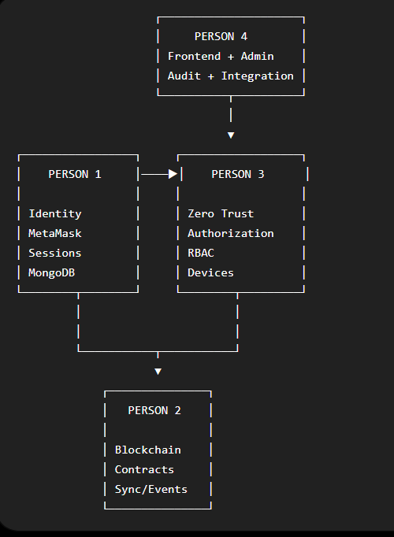
Dependency Between People
Work | Depends Mainly On
MongoDB models | Person 1
MetaMask authentication | Person 1
Identity registration | Person 1 + Person 2
Sessions | Person 1
Smart contracts | Person 2
Blockchain synchronization | Person 2
Zero Trust engine | Person 3 + Person 1
RBAC | Person 3
Device management | Person 3 + Person 1
Admin UI | Person 4 + Persons 1–3 APIs
Audit logging | Person 4 + all backend modules
Audit blockchain anchoring | Person 4 + Person 2
Final integration | Person 4 + all
End-to-end testing | All

Recommended Development Order
Don't wait until one person finishes everything before the others start.
Stage 1 — Foundation
Person 1
- MongoDB
- Identity
- Session models
Person 2
- Smart contracts
Person 3
- Authorization architecture
- Device architecture
Person 4
- Frontend architecture
- Admin dashboard structure
↓
Stage 2 — Core Features
Person 1
→ Authentication + sessions
Person 2
→ Blockchain integration
Person 3
→ Zero Trust + RBAC + devices
Person 4
→ MetaMask UI + admin workflows
↓
Stage 3 — Integration
Person 1
Authentication
↓
Person 3
Authorization
↓
Person 2
Blockchain state
↓
Person 4
Frontend + Audit
↓
Stage 4 — Security Testing
All four people test their own modules first.
Then conduct a combined security test.

Final Feature Ownership
Feature | Owner | Support
MongoDB | P1 | P3/P4
Identity | P1 | P2
MetaMask | P1 | P4
Challenge-response | P1 | P4
Sessions | P1 | P3
IdentityRegistry | P2 | P1
PolicyRegistry | P2 | P3
RevocationRegistry | P2 | P3
Blockchain client | P2 | P1/P3
Blockchain events/cache | P2 | P3
Zero Trust Engine | P3 | P1/P2
RBAC | P3 | P2
Resource authorization | P3 | P4
Device enrollment | P3 | P1/P4
Device replacement | P3 | P4
Device revocation | P3 | P2
Audit logging | P4 | All
Merkle/hash anchoring | P4 | P2
User UI | P4 | P1/P3
Admin UI | P4 | All
Security hardening | All | —
Smart-contract testing | P2 | P3
E2E testing | P4 | All
Final demo | P4 | All

What Each Person Should Be Able to Demonstrate
👤 Person 1
“I can register an identity, connect MetaMask, perform challenge-response authentication, and create/revoke persistent sessions using MongoDB.”
👤 Person 2
“I developed the identity, policy and revocation smart contracts, secured them with OpenZeppelin access control, tested them with Hardhat, and connected blockchain events to the backend.”
👤 Person 3
“I developed the Zero Trust authorization engine, RBAC, resource-level access control, device enrollment/replacement/revocation, and revocation enforcement.”
👤 Person 4
“I developed the user/admin interfaces, audit logging and audit anchoring, integrated all modules, and performed the complete end-to-end demonstration and testing.”

Final Project Flow
If everything is implemented correctly, the four people's work should finally come together like this:
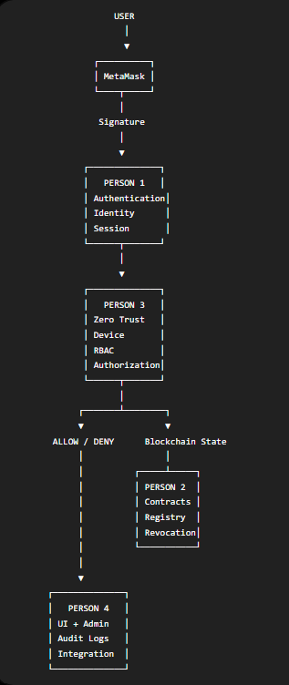
This division covers essentially the entire remaining MVP scope without giving one person only “frontend work” or only “testing work.” Each member gets a technically meaningful contribution that can also be clearly explained during the project viva.

